Water Detector

Description:
The Water Detector is a simple project that helps in monitoring the full water level in a tank.
It uses water sensor to detect water presence. When the water touches the sensor, the Arduino turns ON buzzer to alert the user. This prevents water overflow and dry running of motors.

Block Diagram:
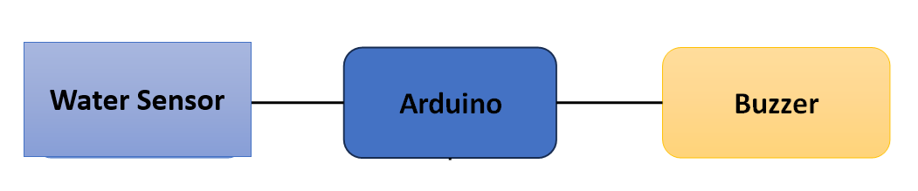

Pinout / Circuit Connection:
- Arduino Pin A0 → water sensor
- Arduino Pin 10 → Buzzer
- Arduino Pin 8,9 → Led
- Power supply: 5V (from Arduino USB or adapter)

Components Required:
- Arduino Uno / Nano
- Water sensor
- 2 x LED (with 220Ω resistor)
- 1 x Buzzer
- Jumper wires
- Breadboard

Working Principle:
The project works on the principle of water conductivity.
When water touches the water sensor, a small current passes through it.
Arduino detects this as an input signal.
- If tank is full → Green LED and Buzzer turn ON.
- If no water is detected → Red led indicate the tank is empty.

Operation (Step-by-Step):
- Insert water sensor at the desired level inside the water tank.
- Upload the Arduino code to the board.
- Connect the components as per the pinout.
- Power ON the system.
- When water touches the probes → LED glows and buzzer beeps.
- When water level drops → alert stops automatically.

Arduino Code:
#define sensorPin A0
#define redLED 8
#define greenLED 9
#define buzzer 10

int threshold = 800; // Adjust after testing (0–1023)

void setup() {
pinMode(redLED, OUTPUT);
pinMode(greenLED, OUTPUT);
pinMode(buzzer, OUTPUT);
Serial.begin(9600);
}

void loop() {
int waterValue = analogRead(sensorPin);
Serial.println(waterValue); // For calibration

if (waterValue >= threshold) { // Tank FULL
digitalWrite(redLED, HIGH);
digitalWrite(greenLED, LOW);
digitalWrite(buzzer, HIGH);
} else { // Tank NOT full
digitalWrite(redLED, LOW);
digitalWrite(greenLED, HIGH);
digitalWrite(buzzer, LOW);
}

delay(500);
}

Conclusion: (Predefined/self-written)
The Water Detector project teaches students how sensors can monitor water levels and trigger outputs like buzzers. Helps in saving water preventing overflow.

For Your References:
[1] Arduino, “Digital Read Function,” Arduino.cc. [Online]. Available: https://www.arduino.cc/reference/en/language/functions/digital-io/digitalread/. [Accessed: 27-Aug-2025].

